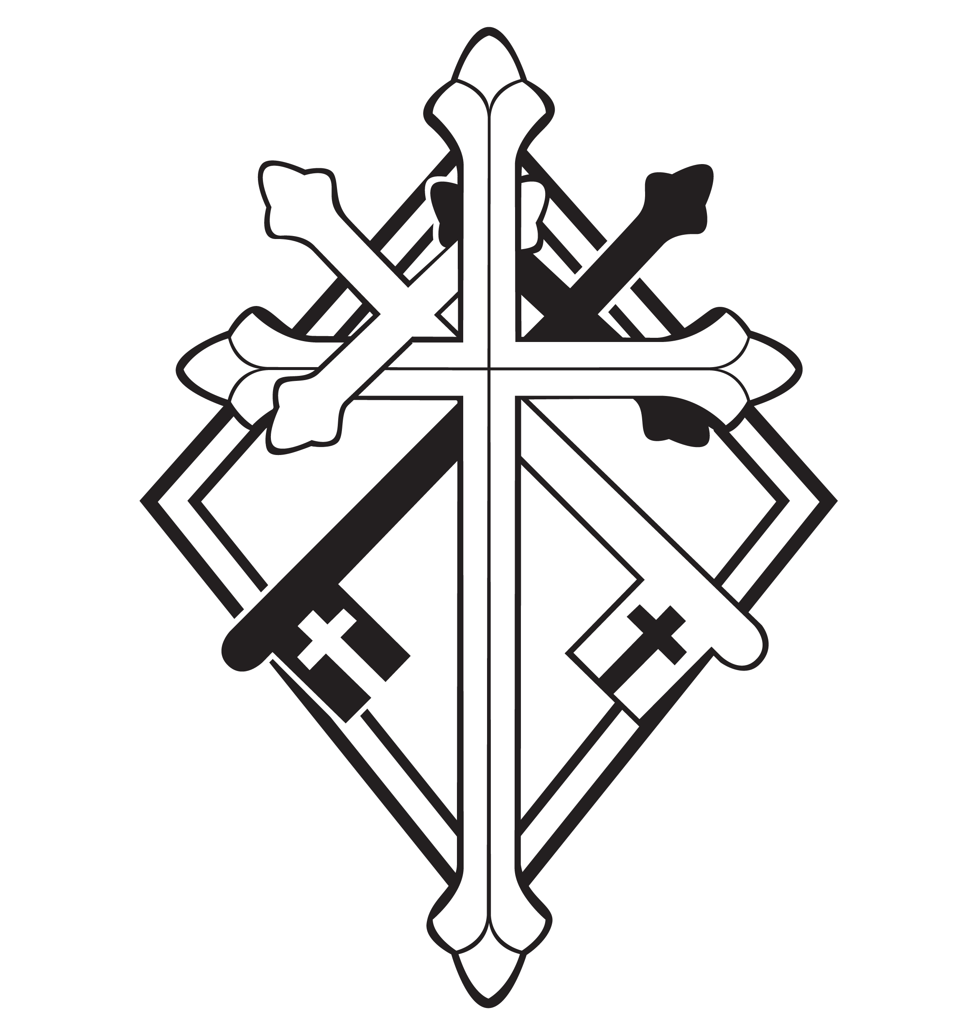
16th Sunday after Pentecost

CHRIST LUTHERAN CHURCH | Lodi, California
September 17, 2023

WELCOME TO WORSHIP
Welcome to Christ Lutheran Church. We pray that your soul will be strengthened by the good news about God’s grace, love, and forgiveness given to us. If you would like to learn more about our church, please speak with our pastor or one of our members after the service.
- Bathrooms are located in the fellowship hall. A changing table is located in the women’s bathroom.
WORSHIP THEME
“Am I my brother’s keeper?” The ironic question Cain asked God when confronted his sin. Cain was his brother’s keeper, and God called him to keep watch over his own soul, too. We have no excuse if we allow sin to reign in our own hearts. We also must give an account for those times that we have allowed sin to reign in the lives of others. Thanks be to God for our Savior, Jesus: the Great Shepherd, overseer, and keeper of our souls.
The Service of the Word and Sacrament
The high and holy worship of God is faith in Jesus Christ. Such faith is created and sustained by God’s service to us (the German, “Gottesdienst,” “God/Divine Service). In the Divine Service, the Lord comes to us in His Word and Sacrament to bless and enliven us with His gifts. The Service is not something we do for God, but His service to us received in faith. The liturgy is God’s work. He gives, we receive.
HYMN God is Here! As We Your People| CW ‘21 858
INVOCATION
M: The grace of our Lord ✙ Jesus Christ and the love of God and the fellowship of the Holy Spirit be with you.
C: And also with you.
CONFESSION
From God’s Word we know that wherever God puts His name, there He is to bless. In the Old Testament the temple was the place where God graciously caused His name to be present (1 Kings 8:27-30).
God has put His name —Father, Son, and Holy Spirit—on us in Holy Baptism. The Divine Service begins with the Invocation, the words spoken over us at our baptisms. Every Divine Service is for the hallowing of the Lord’s name, which the Small Catechism reminds us is done “when the Word of God is taught in its truth and purity, and we, as the children of God, also lead holy lives according to it” (Matthew 28:18-20).
M: God invites us to come into his presence and worship him with humble and penitent hearts. Therefore, let us acknowledge our sinfulness and ask him to forgive us.
C: Holy and merciful Father, I confess that I am by nature sinful, and that I have disobeyed you in my thoughts, words, and actions. I have done what is evil and failed to do what is good. For this I deserve your punishment both now and in eternity. But I am truly sorry for my sins, and trusting in my Savior
Jesus Christ, I pray: Lord, have mercy on me, a sinner.

absolution
M: God, our heavenly Father, has been merciful to us and has given his only Son to be the atoning sacrifice for our sins. Therefore, as a called servant of Christ and by his authority, I forgive you all your sins in the name of the Father and of the Son ✙ and of the Holy Spirit.
C: Amen
LORD, HAVE MERCY - Kyrie
M: For all that we need in life and for the wisdom to use all your gifts with gratitude and joy, hear our prayer, O Lord.
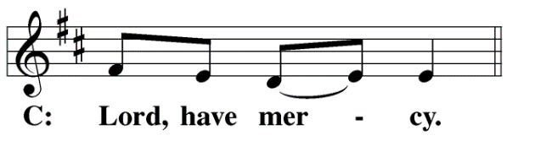
M: For the steadfast assurance that nothing can separate us from your love and for the courage to stand firm against the assaults of Satan and every evil, hear our prayer, O Christ.
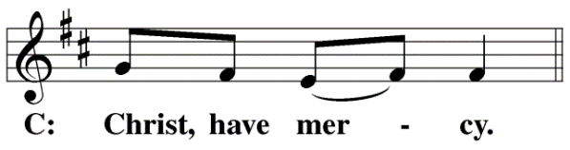

M: For the well-being of your holy Church in all the world and for those who offer here their worship and praise, hear our prayer, O Lord.
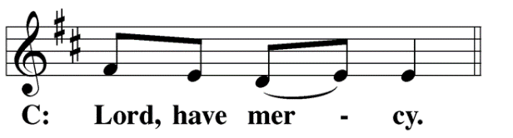
M: Merciful God, maker and preserver of life, uphold us by your power and keep us in your tender care:
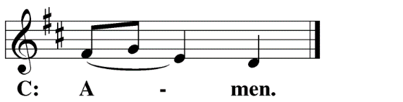
M: The works of the Lord are great and glorious; his name is worthy of praise.
O LORD, OUR LORD
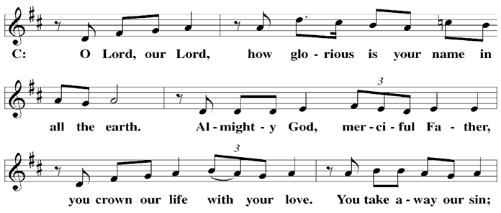

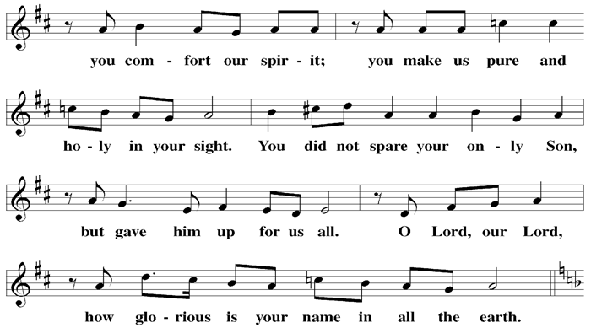

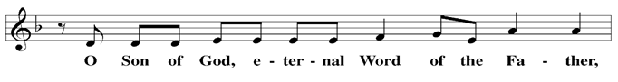

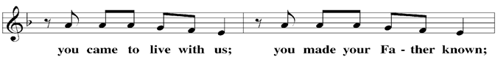

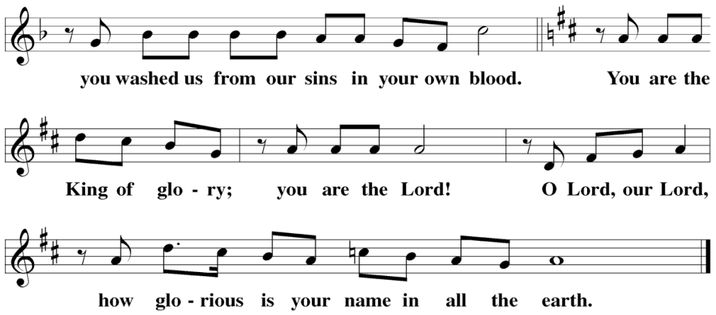

The Service of the Word
Having just received absolution for their sins, believers now gather around the Word of God to find encouragement and peace for their lives on earth.
PRAYER OF THE DAY
M: Let us pray.
Let your continual mercy, O Lord, cleanse and defend your Church; and because it cannot continue in safety without your help, protect and govern it always by your goodness; for you live and reign with the Father and the Holy Spirit, one God, now and forever.
C: Amen
FIRST LESSON Ezekiel 33:7–11
God calls on us to be our brother’s keeper. If we are able to warn someone about their sin and point them to God’s salvation, but don’t; then we are guilty of failing in our calling.
⁷ “Son of man, I have made you a watchman for the people of Israel; so hear the word I speak and give them warning from me. ⁸ When I say to the wicked, ‘You wicked person, you will surely die,’ and you do not speak out to dissuade them from their ways, that wicked person will die for their sin, and I will hold you accountable for their blood. ⁹ But if you do warn the wicked person to turn from their ways and they do not do so, they will die for their sin, though you yourself will be saved.
¹⁰ “Son of man, say to the Israelites, ‘This is what you are saying: “Our offenses and sins weigh us down, and we are wasting away because of them. How then can we live?”’ ¹¹ Say to them, ‘As surely as I live, declares the Sovereign Lord, I take no pleasure in the death of the wicked, but rather that they turn from their ways and live. Turn! Turn from your evil ways! Why will you die, people of Israel?’
PSALM Psalm 51, CW ‘21
SECOND LESSON Romans 13:1–10
God provides us with many keepers. As citizens of earthly kingdoms, God gives us rulers who protect us from evil. We also have the privilege of loving one another as fulfillment of the law.

13 Let everyone be subject to the governing authorities, for there is no authority except that which God has established. The authorities that exist have been established by God. ² Consequently, whoever rebels against the authority is rebelling against what God has instituted, and those who do so will bring judgment on themselves. ³ For rulers hold no terror for those who do right, but for those who do wrong. Do you want to be free from fear of the one in authority? Then do what is right and you will be commended. ⁴ For the one in authority is God’s servant for your good. But if you do wrong, be afraid, for rulers do not bear the sword for no reason. They are God’s servants, agents of wrath to bring punishment on the wrongdoer. ⁵ Therefore, it is necessary to submit to the authorities, not only because of possible punishment but also as a matter of conscience.
⁶ This is also why you pay taxes, for the authorities are God’s servants, who give their full time to governing. ⁷ Give to everyone what you owe them: If you owe taxes, pay taxes; if revenue, then revenue; if respect, then respect; if honor, then honor.
⁸ Let no debt remain outstanding, except the continuing debt to love one another, for whoever loves others has fulfilled the law. ⁹ The commandments, “You shall not commit adultery,” “You shall not murder,” “You shall not steal,” “You shall not covet,” and whatever other command there may be, are summed up in this one command: “Love your neighbor as yourself.” ¹⁰ Love does no harm to a neighbor. Therefore love is the fulfillment of the law.
VERSE OF THE DAY Philippians 4:4
Alleluia. Rejoice in the Lord always; again I will say, Rejoice. Alleluia.
THE GOSPEL Matthew 18:15–20
Jesus gives his church the process of calling a brother or sister to repentance. The goal is always to win them over to the gospel.
¹⁵ “If your brother or sister sins, go and point out their fault, just between the two of you. If they listen to you, you have won them over. ¹⁶ But if they will not listen, take one or two others along, so that ‘every matter may be established by the testimony of two or three witnesses.’ ¹⁷ If they still refuse to listen, tell it to the church; and if they refuse to listen even to the church, treat them as you would a pagan or a tax collector.
¹⁸ “Truly I tell you, whatever you bind on earth will be bound in heaven, and whatever you loose on earth will be loosed in heaven.
¹⁹ “Again, truly I tell you that if two of you on earth agree about anything they ask for, it will be done for them by my Father in heaven. ²⁰ For where two or three gather in my name, there am I with them.”

M This is the Gospel of the Lord.
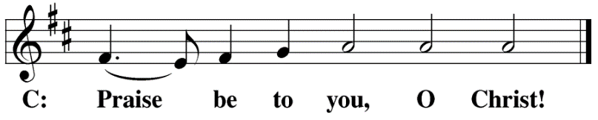

HYMN OF THE DAY Lord of All Nations, Grant Me Grace| CW ‘21 768
SERMON Romans 13
NICENE CREED
Having heard the Word of God, we confess our faith in His name. The creed is our saying back to God what He has first said to us. In the Creed we acclaim the truth of the triune God and His work of salvation accomplished for us in His incarnate Son, Jesus Christ.
We believe in one God, Dt. 6:4
the Father, the Almighty, 2 Cor. 6:18
maker of heaven and earth, Is. 51:13
The Nicene Creed is the great Confession of the Christian faith professed by all Christians. The Creed originated at the First Council of Nicaea (c. AD. 325)
of all that is, seen and unseen. Col. 1:16
We believe in one Lord, Jesus Christ, 1 Cor 8:6
the only Son of God, Jn. 3:16
eternally begotten of the Father, Heb. 1:2,5
God from God, Light from Light, true God from true God, Jn. 1
begotten, not made, of one being with the Father. Jn. 10:30
Through him all things were made. Jn. 1:3
For us and for our salvation, 1 Th. 5:9
he came down from heaven, Jn. 6:38
was incarnate of the Holy Spirit and the virgin Mary, Lk. 1:35
The Creed itself was crafted as a confession of Scripture in opposition to the Arian heresy, which denied that the Lord Jesus and the Holy Spirit are God.

and became fully human. Gal. 4:4
For our sake he was crucified under Pontius Pilate. Mk. 15:15
He suffered death and was buried. 1 Cor. 15:3-4a
On the third day he rose again in accordance
with the Scriptures. 1 Cor. 15:4b
He ascended into heaven Ac. 2:33-34
and is seated at the right hand of the Father. Heb. 1:13
He will come again in glory Mt. 25:31
to judge the living and the dead, 2 Tim. 4:1
and his kingdom will have no end. Lk. 1:33
We believe in the Holy Spirit, the Lord, the giver of life, Job 33:4
who proceeds from the Father and the Son, Jn. 15:26
who in unity with the Father and the Son Jn. 4:24
is worshiped and glorified,
who has spoken through the prophets. 2 Pet. 1:25
We believe in one holy Christian Mt. 16:18; Eph. 2:19-20
and apostolic Church.
We acknowledge one baptism for the forgiveness of sins. Eph. 4:5; Ac. 2:38
We look for the resurrection of the dead 1 Cor. 15:21-22
and the life of the world to come. Amen. Rev. 22

OFFERING
In response to God’s love and forgiveness, we give back a portion of what he has given us. The members of Christ Lutheran Church have joined to proclaim the gospel to this community. These offerings support that work. While our guests are welcome to participate, they should not feel obligated to do so.
PRAYER OF THE CHURCH
M: Almighty God and Father, we thank you for all your mercies, especially for the gift of your Son, through whom you have revealed your gracious will. We praise you for the Holy Spirit and his working through the means of grace.
C: Plant your Word in our hearts, and cause it to produce fruit in our lives.
M: Strengthen and defend your Church, that by your Word and sacraments faith may grow and love toward all may increase.
C: Support all who spread the light of your truth throughout the world.
M: Keep our children in the grace of their baptisms. Enable their parents to train them in lives of faith.
C: Raise up Christians to serve you in the ministry of the Word and in all godly walks of life.
M: Preserve our nation in justice and honor. Guide and bless all who make, administer, and judge our laws.
C: Give them wisdom to promote justice and hinder evil.

M: Let your blessing rest on planting and harvest, commerce and industry, medicine and science, the arts and culture. Protect all who travel, and care for those whose work is difficult or dangerous.
C: Be with all who devote themselves to any useful task.
M: Comfort all who are in sorrow or need, sickness or adversity. Remember those who suffer persecution for the faith. Have mercy on those to whom death draws near.
C: Grant them your love and keep them in your tender care.
M: We remember with thanksgiving those who have loved and served you, who now rest from their labors. Console those who are mourning or living with sadness.
C: Keep us in the true faith, and bring us at last to the joys of our eternal home.
M: Grant us these things, Father, for your Son’s sake. In His name we join to pray:

LORD’S PRAYER Matthew 6:9-13; Luke 11:2-4
C: Our Father, who art in heaven,
hallowed be thy name,
thy kingdom come,
thy will be done on earth as it is in heaven.
Give us this day our daily bread;
and forgive us our trespasses,
as we forgive those
who trespass against us;
and lead us not into temptation,
but deliver us from evil.
For thine is the kingdom
and the power and the glory
forever and ever. Amen.

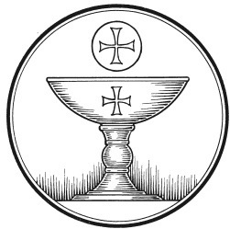
The Service of the Sacrament
This greeting marks a new service, so to speak. These ancient introductory words & phrases help to highlight, celebrate and bring attention to the Sacrament.
M: The Lord be with you.
C: And also with you.
M: Lift up your hearts.
C: We lift them up to the Lord.
M: Let us give thanks to the Lord our God.
C: It is right to give him thanks and praise.
M: Praise to the God and Father of our Lord Jesus Christ! In love he has blessed us with every spiritual blessing. He sends the Holy Spirit to testify that we are his children and to strengthen us when we are weak. Now have come the salvation and the power and the kingdom of our God and the authority of his Christ. To him who sits on the throne and to the Lamb be praise and thanks and honor and glory for ever and ever:

HOLY, HOLY, HOLY – Sanctus
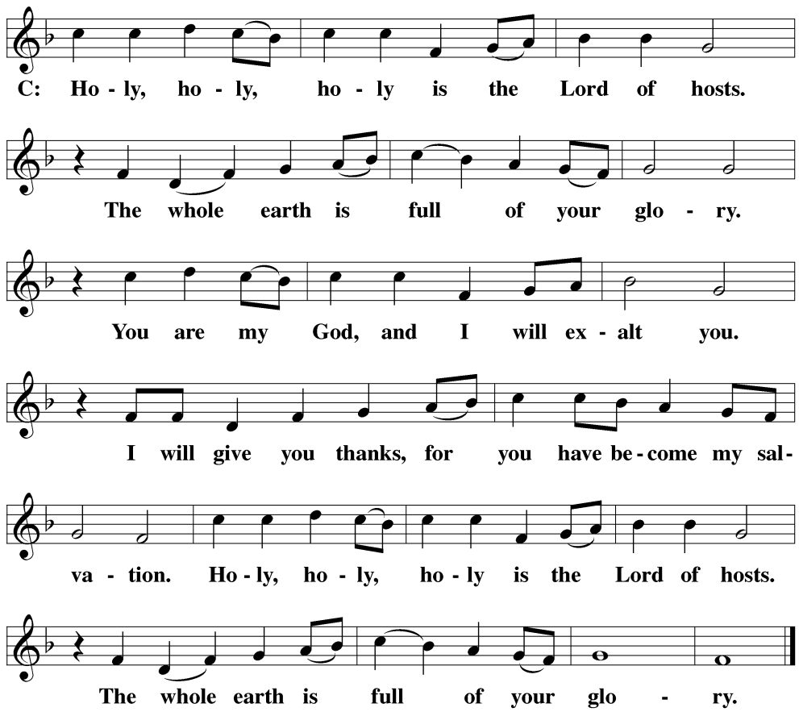

WORDS OF INSTITUTION Matthew 26, Mark 14, Luke 22
M: Our Lord Jesus Christ, on the night he was betrayed, took bread; and when he had given thanks, he broke it and gave it to his disciples, saying: “Take and eat. This is my ✙ body, which is given for you. Do this in remembrance of me.”
The Words of institution both proclaim the words of Jesus to the congregation and sets apart the bread and wine for the Lord’s Supper.
Then he took the cup, gave thanks, and gave it to them, saying, “Drink from it all of you; this is my ✙ blood of the new covenant, which is poured out for you for the forgiveness of sins. Do this, whenever you drink it, in remembrance of me.”

PEACE OF THE LORD – Pax Domini John 20:19
M: The peace of the Lord be with you always.
C: Amen

O CHRIST, LAMB OF GOD – Agnus Dei John 1:29
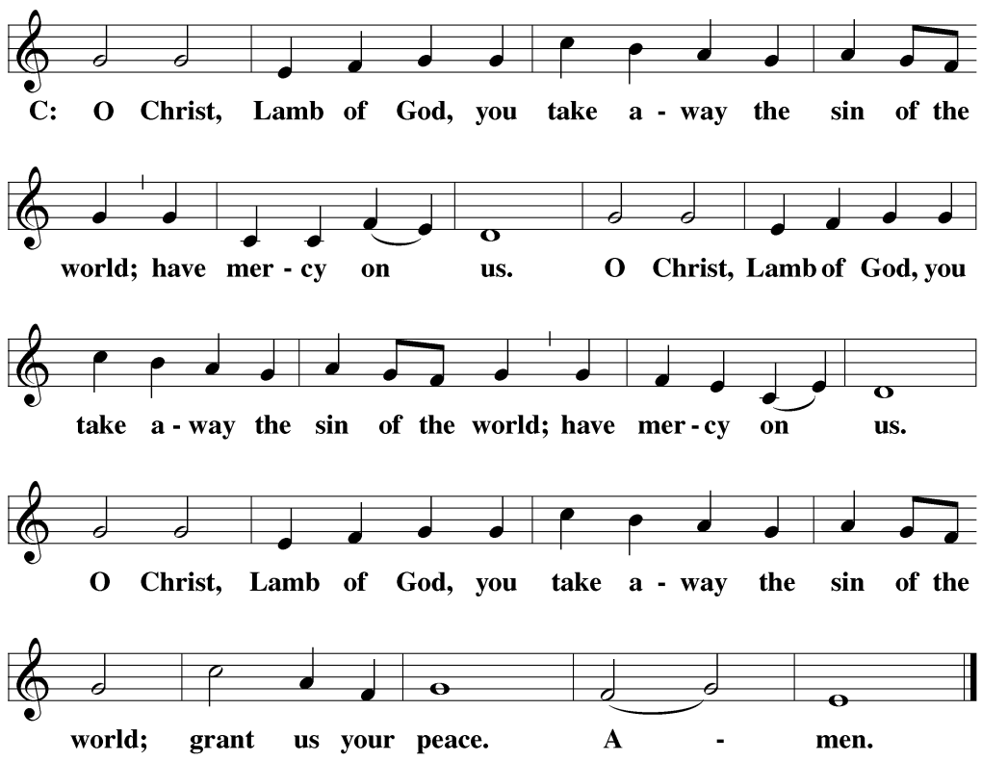
DISTRIBUTION
Those who will be receiving Holy Communion today may wish to read Personal Preparation for Holy Communion, found on page 156 in the front section of the hymnal. This page helps us put into practice what the Bible encourages: “Everyone ought to examine themselves before they eat of the bread and drink from the cup.” (1 Corinthians 11:28)
Christ Lutheran Church confesses and practices the Biblical teaching of a Closed Communion. We ask that only members of the Wisconsin Synod [WELS] or the Evangelical Lutheran Synod [ELS] join us at the Lord’s Table. If you have questions concerning our communion practice, or would like to inquire about how you, too, can commune with us, please speak with the Pastor following the service.

THANK THE LORD
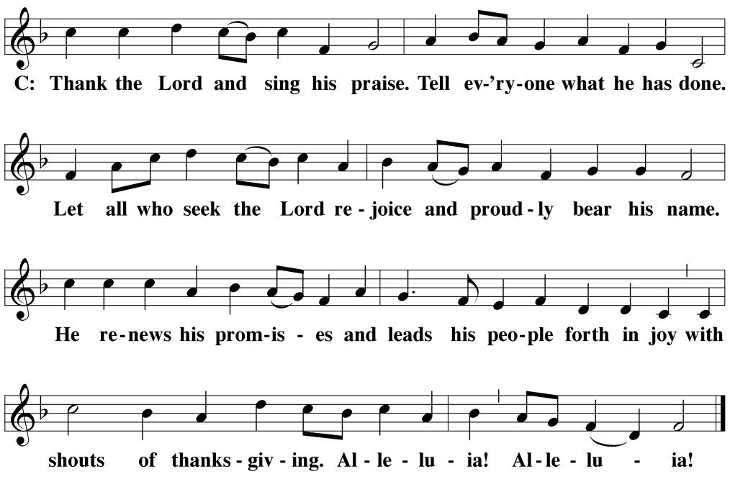
M: Hear the prayer of your people, O Lord, that the lips which have praised you here may glorify you in the world, that the eyes which have seen the coming of your Son may long for his coming again, and that all who have received in his true body and blood the pledge of your forgiveness may be restored to live a new and holy life, through Jesus Christ, our Lord, who lives and reigns with you and the Holy Spirit, one God, now and forever.
C: Amen.

THE BLESSING
M: Brothers and sisters, go in peace. Live in harmony with one another. Serve the Lord with gladness.
The Lord bless you and keep you.
The Lord make his face shine on you and be gracious to you.
The Lord look on you with favor and ✙ give you peace.
C: Amen.
CLOSING HYMN Jesus Sinners Does Receive | CW ’21 654

COPYRIGHT INFORMATION
Content requiring a copyright license is reproduced under OneLicense.net #A-718312. All rights reserved. The Common Service: Texts revised from The Lutheran Hymnal, 1941. Music revised by James Engel. Scripture Quotations: From the Holy Bible, New International Version (NIV 1984), © 1973, 1978, 1984 by Biblica, Inc.

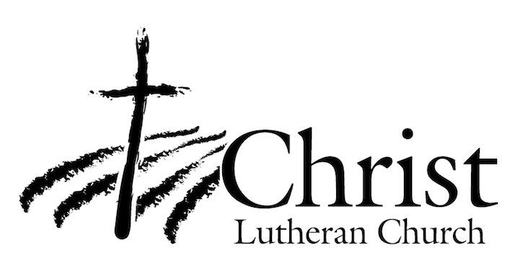
13009 N. Elderberry Ct.
Lodi, CA 95242
www.christlodi.org
209-368-6250
Pastor Tim Leistekow
WELCOME TO CHRIST EV. LUTHERAN CHURCH!
We preach a message of forgiveness, hope and peace
through the death and resurrection of Jesus Christ.
Families and individuals of all ages will find opportunities
both to grow and to serve.
Our mission statement:
Look what Christ is doing!
He binds us together in fellowship
He gathers us in for worship
He builds us up for service
He sends us out with the gospel

“Now you are the body of Christ,
and each one of you is a part of it.”
(1 Corinthians 12:27)

